# Specification Mass Update – Users Guide

## Introduction

The specification mass update is a self-sufficient web page that can be hosted in inRiver iPMC as a e.g. Application Template, Portal Template, etc. Its function is as the name applies a specification mass update on any number for specification fields with the same value.

## Workflow

### Work area

The first thing that needs to be set up in Enrich is a work area. It should be under Common Shared. The work area is used because it is a powerful way to select entities with the desired templates.

### Selecting a Specification

Once the work areas are set up then the Specification template must be selected to actually Mass Update the values of the template.

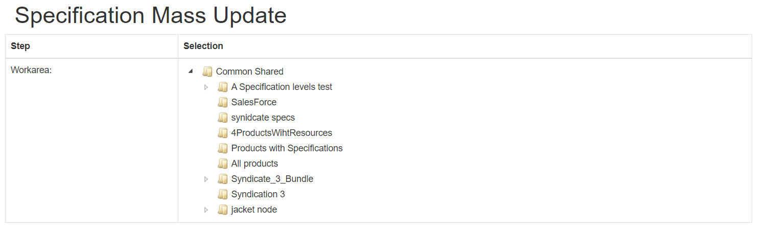

Once a work area is selected the next step is to select which Specification template you want to make a mass update on.

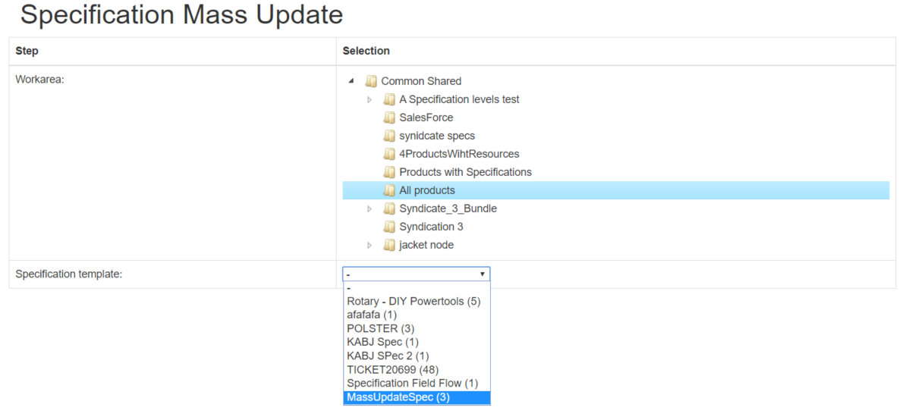

In this case the work area “All products” contains entities (Products) that have the listed Specification templates defined on them. The number within parentheses are the number of entities that are included in that specific Specification template.

Once the template is selected the fields of that template is shown with checkboxes.

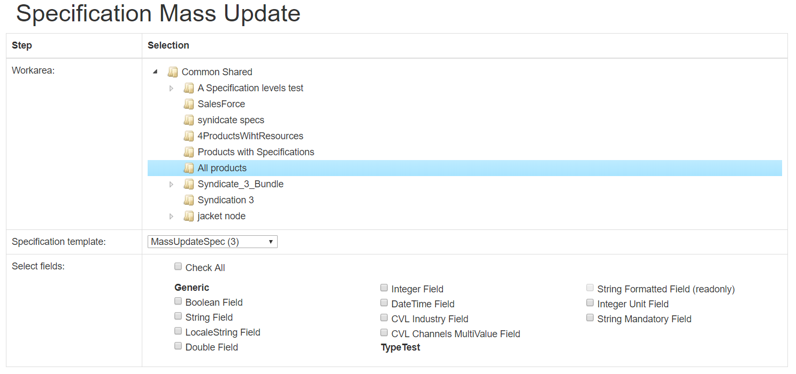

Each Specification template field name is listed under “Selected fields:”. In the above picture the fields have been named in order to identify the DataType used for each field. So, in Enrich the above selected Specification template is looking like this:

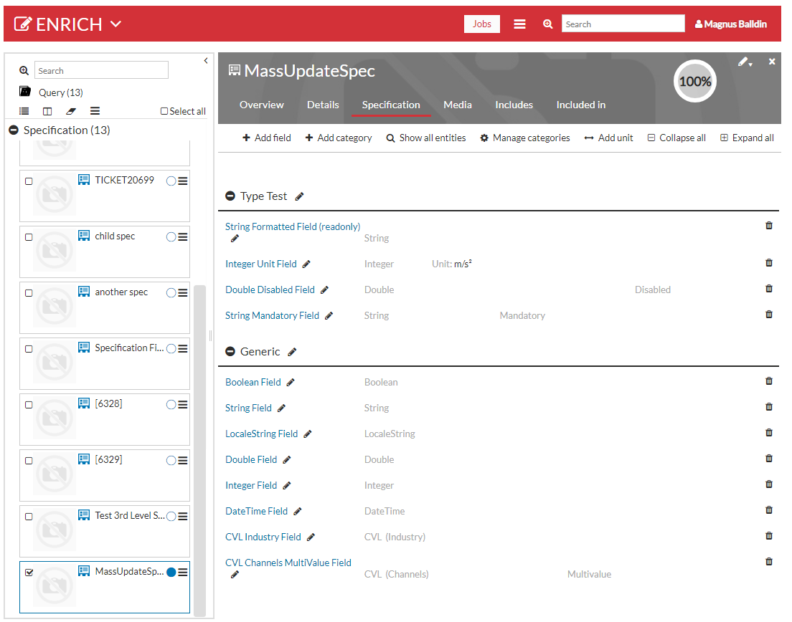

Select (by checking) the fields you want to update. Also, all fields can be selected at the same time by checking the field Check All.

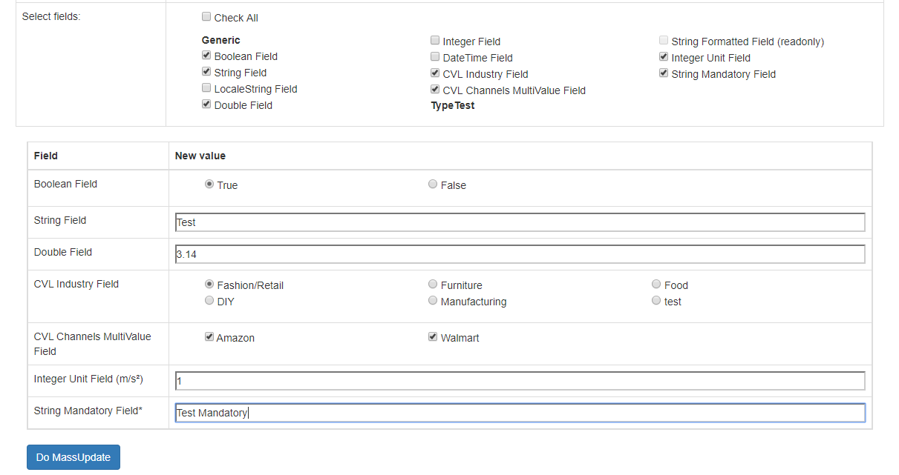

Fill in the fields and click the “Do Mass Update Button”. When clicking the button each of the (3) entities that are included in that specification template will be updated with the values that you entered. If a field is empty it will be ignored during the mass update.

There is validation support for the fields. Each field that is not valid is marked by a red rectangle.

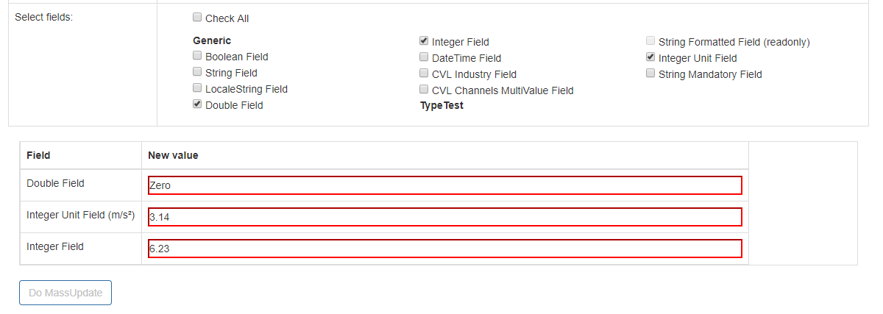

If you have entered non valid values it is not possible to do a mass update.